## **Guided LAB - 305.1.1 - Installing Maven on Windows**

## 

## **Introduction**

## Apache Maven is a build-automation tool designed to provide a comprehensive and easy-to-use way of developing Java applications. It uses a POM (Project Object Model) approach to create a standardized development environment for multiple teams.

**Lab Overview:**

## In this tutorial, we will demonstrate installation of Apache Maven on a system that is running Windows. By the end of this lab, learners will be able to install Apache Maven on a Windows system.

## **Prerequisites:**

## A system running Windows.

## A working Internet connection.

## Access to an account with administrator privileges.

## Access to the command prompt.

## **Instructions:**

## **Step 1) Install JDK and Add ‘JAVA_HOME’ Environment Variable**

If Java JDK is installed in your system, You can skip ***Step 1.***

To install Java, [download the JDK installer](http://www.oracle.com/technetwork/java/javase/downloads/index.html) and add/update the JAVA_HOME variable to the JDK install folder.

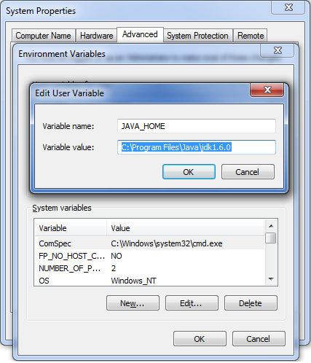

## 

## **Step 2) Download Maven and add *‘MAVEN_HOME’* and ‘*M2_HOME*’ Environment Variables.**

Visit the [Maven download page](https://maven.apache.org/download.cgi) and download the version of Maven you want to install.

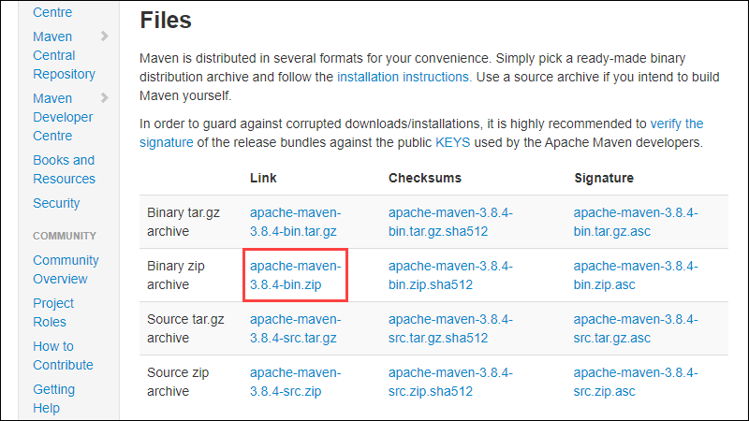

It has been extracted in location – D:/Latest Setup/apache-maven-3.0.4. You can choose your own location.

We add both ***M2_HOME***and ***MAVEN_HOME*** variables to the Windows environment using **system properties** and point them to our Maven installation folder as shown in the screenshot below:

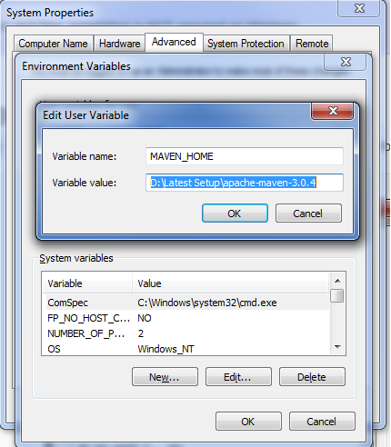

## 

## **Step 3) Include ‘maven/bin’ directory in the ‘PATH’ variable.**

To run Maven from a command prompt, this is necessary. Update the PATH variable with the 'Maven-installation_folder/bin' directory.

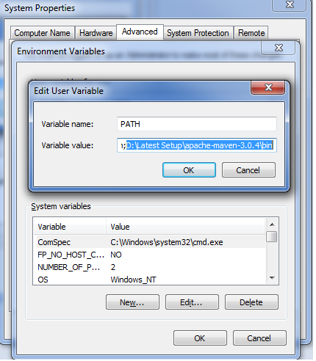

## 

## **Step 4) Verify maven in console**

Maven installation is completed. Now let's test it from the Windows command prompt.

1. Go to the start menu and type cmd in the application location search box.
2. Press ENTER. A new command prompt will be opened.
3. Type mvn -version in command prompt and hit ENTER.

|  |
| --- |

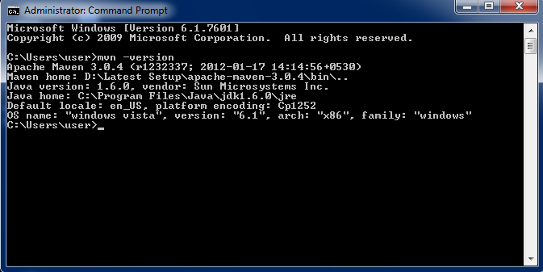

This should show the version information of Maven installed. If there is any error shown, cross-check all of the above steps.

**Conclusion**

After this lab, you should have a copy of Maven installed and ready to use on your Windows system.

Reference:

<https://phoenixnap.com/kb/install-maven-windows>